recipe of the week, Gluten Free Recipe of the Week, challenge of the week, Recipe Challenge Winner of the Week, Recipe Fail Winner of the Week

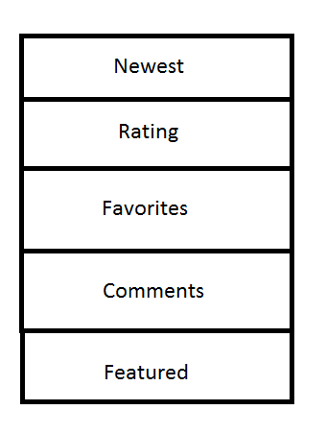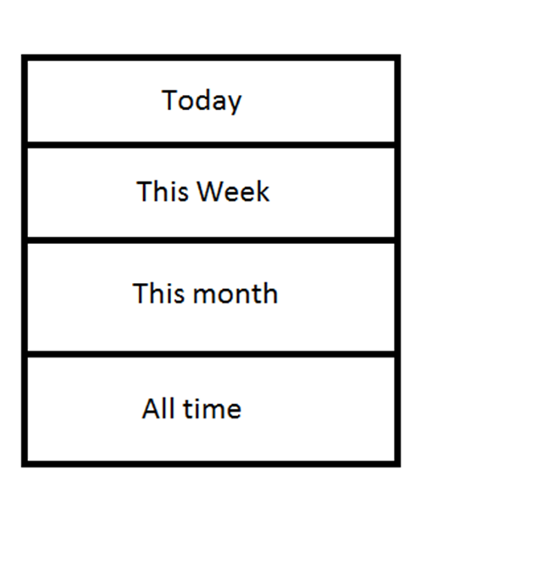

I want to be able to have a drop box with these options to filter out which recipes go where for each of the following categories:

* Recipe of the Week
* Gluten Free Recipe of the Week
* Recipe Challenge Winner of the Week
* Recipe Fail Winner of the Week

The filter allows the users to be able to see which recipes are in those categories. I would like the default category to be Rating and Today.

For Recipe Fail Winner of the Week and Recipe Challenge Winner of the Week I would like a separate upload section for the pictures. They are only for those two portions of the website but users can save the recipe to their cookbook if they want.